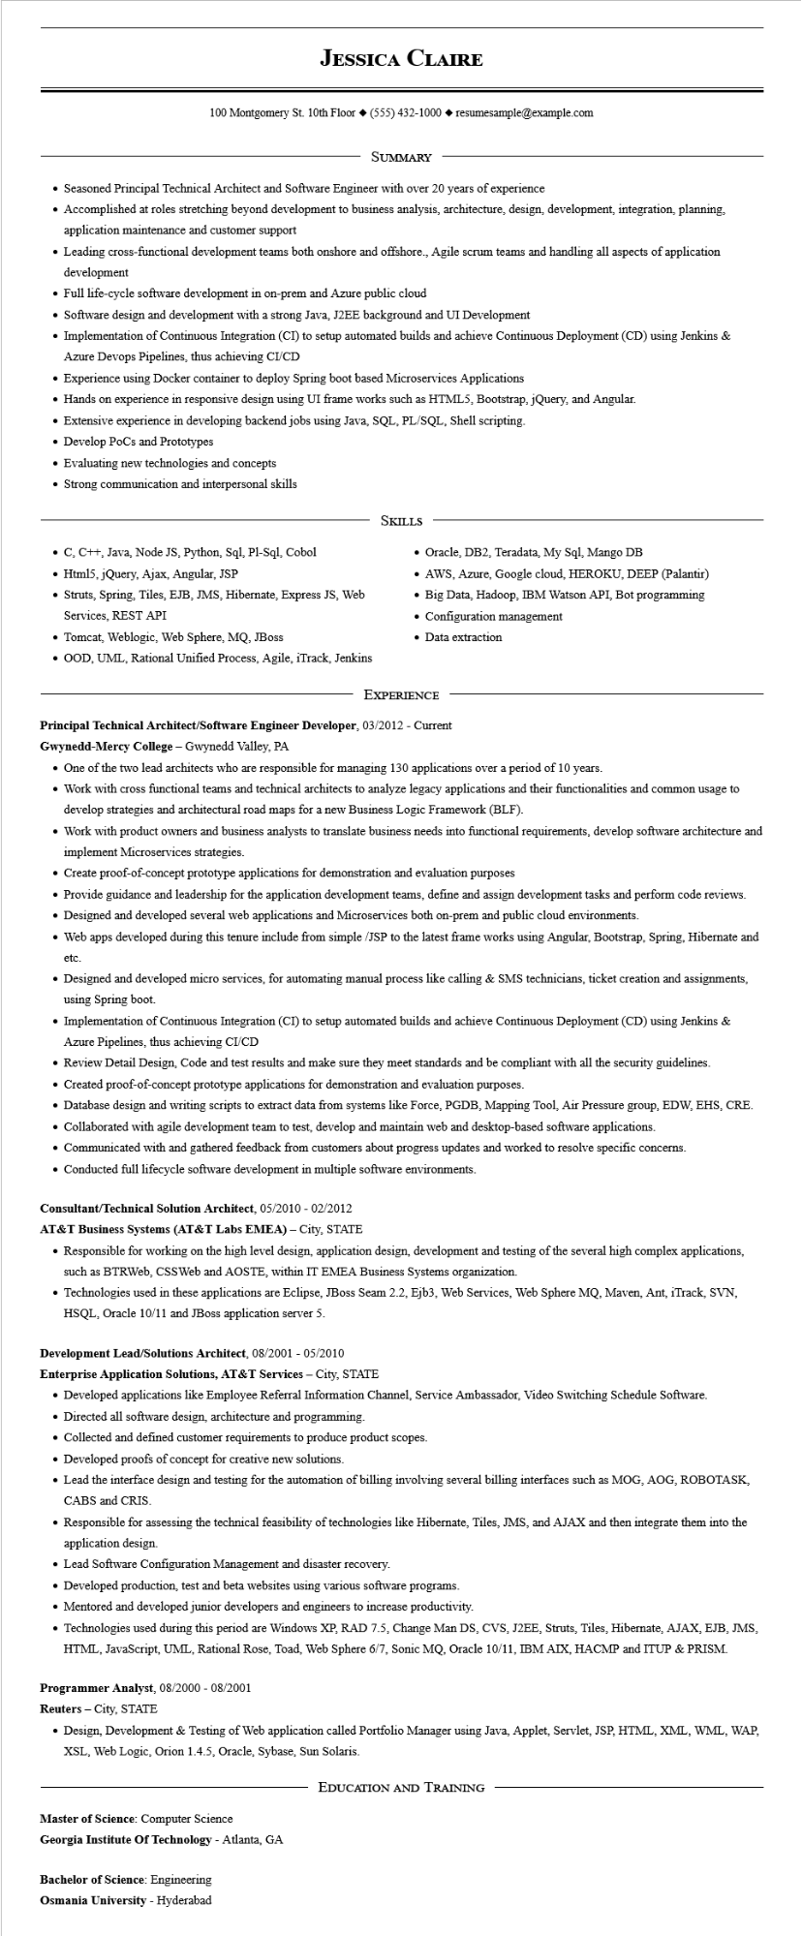
JESSICA CLAIRE
100 Montgomery St. 10th Floor (555) 432-1000◆ resumesample@example.com
SUMMARY
• Seasoned Principal Technical Architect and Software Engineer with over 20 years of experience
• Accomplished at roles stretching beyond development to business analysis, architecture, design, development, integration, planning, application maintenance and customer support
• Leading cross-functional development teams both onshore and offshore., Agile scrum teams and handling all aspects of application development
• Full life-cycle software development in on-prem and Azure public cloud
• Software design and development with a strong Java, J2EE background and UI Development
• Implementation of Continuous Integration (CI) to setup automated builds and achieve Continuous Deployment (CD) using Jenkins & Azure Devops Pipelines, thus achieving CI/CD
• Experience using Docker container to deploy Spring boot based Microservices Applications
• Hands on experience in responsive design using UI frame works such as HTML5, Bootstrap, jQuery, and Angular.
• Extensive experience in developing backend jobs using Java, SQL, PL/SQL, Shell scripting.
• Develop PoCs and Prototypes
• Evaluating new technologies and concepts
• Strong communication and interpersonal skills
• C, C++, Java, Node JS, Python, Sql, Pl-Sql, Cobol Html5, jQuery, Ajax, Angular, JSP
• Struts, Spring, Tiles, EJB, JMS, Hibernate, Express JS, Web Services, REST API
• Tomcat, Weblogic, Web Sphere, MQ, JBoss
•OOD, UML, Rational Unified Process, Agile, iTrack, Jenkins
SKILLS
• Oracle, DB2, Teradata, My Sql, Mango DB
• AWS, Azure, Google cloud, HEROKU, DEEP (Palantir)
• Big Data, Hadoop, IBM Watson API, Bot programming • Configuration management
• Data extraction
EXPERIENCE
Principal Technical Architect/Software Engineer Developer, 03/2012 - Current
Gwynedd-Mercy College - Gwynedd Valley, PA
• One of the two lead architects who are responsible for managing 130 applications over a period of 10 years.
• Work with cross functional teams and technical architects to analyze legacy applications and their functionalities and common usage to develop strategies and architectural road maps for a new Business Logic Framework (BLF).
• Work with product owners and business analysts to translate business needs into functional requirements, develop software architecture and implement Microservices strategies.
• Create proof-of-concept prototype applications for demonstration and evaluation purposes
• Provide guidance and leadership for the application development teams, define and assign development tasks and perform code reviews.
• Designed and developed several web applications and Microservices both on-prem and public cloud environments.
• Web apps developed during this tenure include from simple /JSP to the latest frame works using Angular, Bootstrap, Spring, Hibernate and
etc.
• Designed and developed micro services, for automating manual process like calling & SMS technicians, ticket creation and assignments, using Spring boot.
• Implementation of Continuous Integration (CI) to setup automated builds and achieve Continuous Deployment (CD) using Jenkins & Azure Pipelines, thus achieving CI/CD
• Review Detail Design, Code and test results and make sure they meet standards and be compliant with all the security guidelines.
• Created proof-of-concept prototype applications for demonstration and evaluation purposes.
• Database design and writing scripts to extract data from systems like Force, PGDB, Mapping Tool, Air Pressure group, EDW, EHS, CRE.
• Collaborated with agile development team to test, develop and maintain web and desktop-based software applications.
• Communicated with and gathered feedback from customers about progress updates and worked to resolve specific concerns.
• Conducted full lifecycle software development in multiple software environments.
Consultant/Technical Solution Architect, 05/2010- 02/2012
AT&T Business Systems (AT&T Labs EMEA) - City, STATE
• Responsible for working on the high level design, application design, development and testing of the several high complex applications, such as BTRWeb, CSSWeb and AOSTE, within IT EMEA Business Systems organization.
• Technologies used in these applications are Eclipse, JBoss Seam 2.2, Ejb3, Web Services, Web Sphere MQ, Maven, Ant, iTrack, SVN, HSQL, Oracle 10/11 and JBoss application server 5.
Development Lead/Solutions Architect, 08/2001 - 05/2010
Enterprise Application Solutions, AT&T Services - City, STATE
• Developed applications like Employee Referral Information Channel, Service Ambassador, Video Switching Schedule Software.
• Directed all software design, architecture and programming.
• Collected and defined customer requirements to produce product scopes.
• Developed proofs of concept for creative new solutions.
• Lead the interface design and testing for the automation of billing involving several billing interfaces such as MOG, AOG, ROBOTASK, CABS and CRIS.
• Responsible for assessing the technical feasibility of technologies like Hibernate, Tiles, JMS, and AJAX and then integrate them into the application design.
• Lead Software Configuration Management and disaster recovery.
• Developed production, test and beta websites using various software programs.
• Mentored and developed junior developers and engineers to increase productivity.
• Technologies used during this period are Windows XP, RAD 7.5, Change Man DS, CVS, J2EE, Struts, Tiles, Hibernate, AJAX, EJB, JMS, HTML, JavaScript, UML, Rational Rose, Toad, Web Sphere 6/7, Sonic MQ, Oracle 10/11, IBM AIX, HACMP and ITUP & PRISM.
Programmer Analyst, 08/2000 - 08/2001
Reuters - City, STATE
• Design, Development & Testing of Web application called Portfolio Manager using Java, Applet, Servlet, JSP, HTML, XML, WML, WAP, XSL, Web Logic, Orion 1.4.5, Oracle, Sybase, Sun Solaris.
Master of Science: Computer Science
Georgia Institute Of Technology - Atlanta, GA
Bachelor of Science: Engineering
Osmania University - Hyderabad
EDUCATION AND TRAINING

